TASK 1
INCLUDE Irvine32.inc

.code
main PROC
;EAX * 21
;EAX = (EAX*2^4) + (EAX*2^2) + (EAX*2^0)

mov eax, 10 ;Assuming Eax is 10

shl eax, 4
mov ebx, 10
shl ebx, 2
add eax, ebx
mov ebx, 10
add eax, ebx

call writedec
call crlf

exit
main ENDP

END main
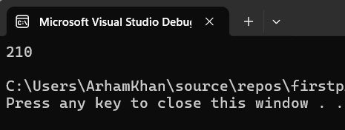

TASK 2
INCLUDE Irvine32.inc

.data
numExpand sdword -128

.code
main PROC
mov ax, word PTR numExpand ; 1111111110000000 (16 bits - 2's complement form)
movsx eax, ax ; 1111111111111111 1111111110000000 (32 bits)

mov bx, ax ; Move -128 into BX -> 1111111110000000
shl ebx, 16 ; Shift left 16 bits to make room for the upper half -> 1111111110000000 0000000000000000
ror ax, 16 ; Rotate AX right 16 bits -> 0000000000000000 1111111110000000
or eax, ebx ; Combine the upper and lower halves -> 1111111111111111 1111111110000000
; 0000000000000000 1111111110000000
; -----------------------------------
; = 1111111111111111 1111111110000000

call writeint
call crlf
exit

main ENDP
END main

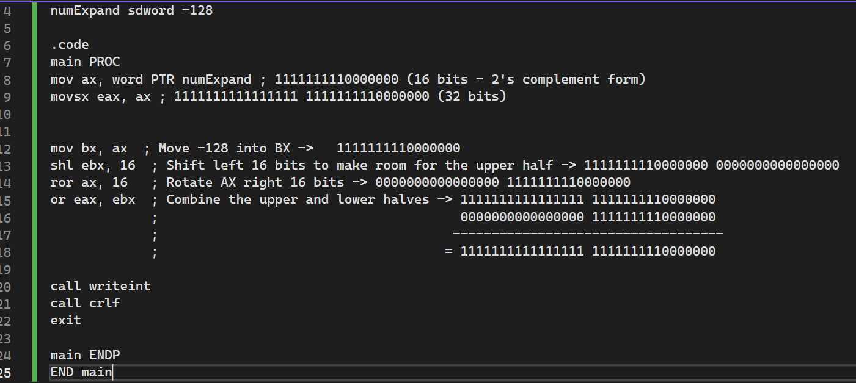

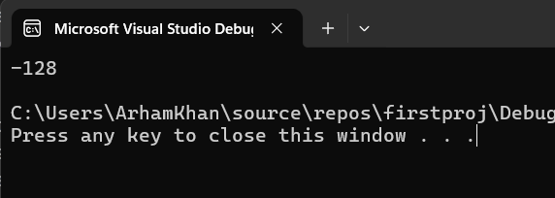

TASK 3
INCLUDE Irvine32.inc

.data
timeValue word 1A2Bh ; 0001101000101011 (This is example value)
bMinutes byte ?

.code
main PROC
; Extract minutes from the time field
mov ax, timeValue ; Move the time stamp field into AX
shr ax, 5 ; 0000000011010001
and ax, 3Fh ;clear higher bits after the 10th bit position 0000000011010001
; 00111111
mov bMinutes, al

movzx eax, bMinutes
call writedec
call crlf

exit
main ENDP
END main

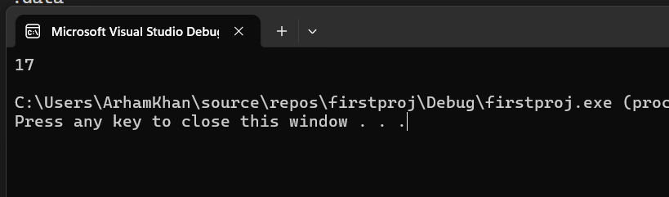

TASK 4
INCLUDE Irvine32.inc
.data
s word 2315h
s1 word 8573h
.code
main PROC

;without SHRD

mov ax, s
mov bx, s1
shl ax, 88
shr bx, 7
or bx, ax
call dumpregs
exit

main ENDP
END main
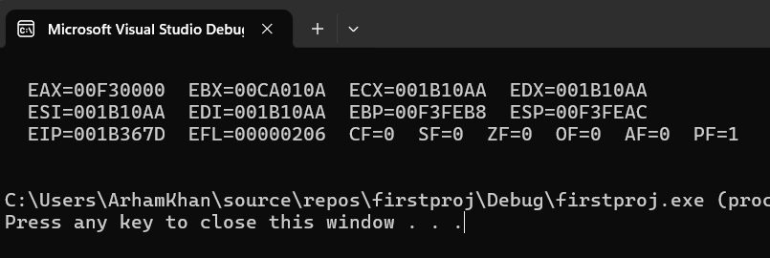
INCLUDE Irvine32.inc
.data
s WORD 7575h
s1 WORD 2341h
.code
main PROC
;with SHRD
mov ax, s
mov bx, s1
shrd bx, ax, 1
call dumpregs
exit

main ENDP
END main
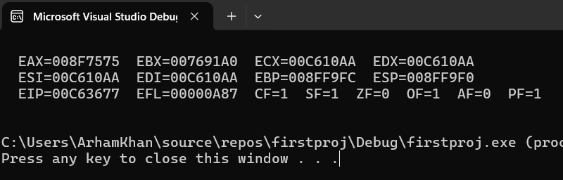
TASK 5:
INCLUDE Irvine32.inc

.data
int1 dword 10
int2 dword 4
int3 dword 2
.code
main PROC
mov eax, int1
cdq
mov ebx, int3
idiv ebx
mov ecx,eax
mov eax, int1
cdq
mov ebx, int3
idiv ebx

mov eax,ecx
imul eax,ebx
mov int1,eax
call writeint
exit
main ENDP

END main
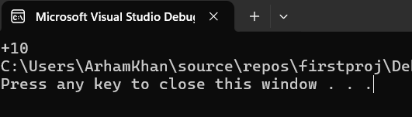
TASK 6:
INCLUDE Irvine32.inc

.data
int1 dword 12
int2 dword 98
result dword 0

.code

main PROC
call Extended_Add
exit
main ENDP

Extended_Add PROC
mov eax,int1
add eax,int2
call writeint
mov result,eax
ret
Extended_Add ENDP

END main
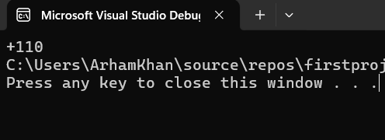
TASK 7:
INCLUDE Irvine32.inc

.data
prompt byte "Enter an integer (1 to stop): ", 0
primeMsg byte "The number is prime.", 0dh, 0ah, 0
notPrimeMsg byte "The number is not prime.", 0dh, 0ah, 0

.code
main PROC
mov ecx, 0

mov edx, offset prompt
call writestring
call crlf
InputLoop:
call ReadInt
cmp eax, 1
je ExitProgram
call IsPrime
jc Is_Prime
mov edx, OFFSET notPrimeMsg
call WriteString
jmp InputLoop

Is_Prime:
mov edx, OFFSET primeMsg
call WriteString
jmp InputLoop

ExitProgram:
exit

IsPrime PROC
cmp eax, 2
jl NotPrime
cmp eax, 2
je Prime
test eax, 1
jz NotPrime

mov ecx, eax
shr ecx, 1
mov ebx, 2

CheckLoop:
cmp ebx, ecx
jg Prime
mov edx, 0
div ebx
cmp edx, 0
je NotPrime
inc ebx
jmp CheckLoop

Prime:
stc
ret

NotPrime:
clc
ret

IsPrime ENDP

main ENDP
END main
